Temasek Polytechnic
School of Informatics and IT

Diploma in Information Technology (IT)

Software Design Specifications (SDS)

Project Particulars

Tutor | Mr Qi Yutao
Class | P02
Project Title | Delonix Regia Hotel Management System

Project Team’s Particulars

Matric Number | Student Name
1301676A | Mohamed Nisar Faizal
1301183H | Ronald Ng
1300506A | Syazwani binte Saharoni
1307306I | Mervin Neo

Table of Contents

1. DISTRIBUTION OF WORKLOAD 3
2. ARCHITECTURE DESIGN 3
3. USER INTERFACE (UI) DESIGN 4
4. PROGRAM DESIGN 8
5. DATABASE DESIGN 11
References 16

DISTRIBUTION OF WORKLOAD

Design | Members
Architecture | Faizal
User Interface | Mervin
Program | Syazwani
Database | Ronald

ARCHITECTURE DESIGN

The proposed system architecture will follow the 2-tier (i.e. Client-Server) design. Below is the diagram of the architecture.

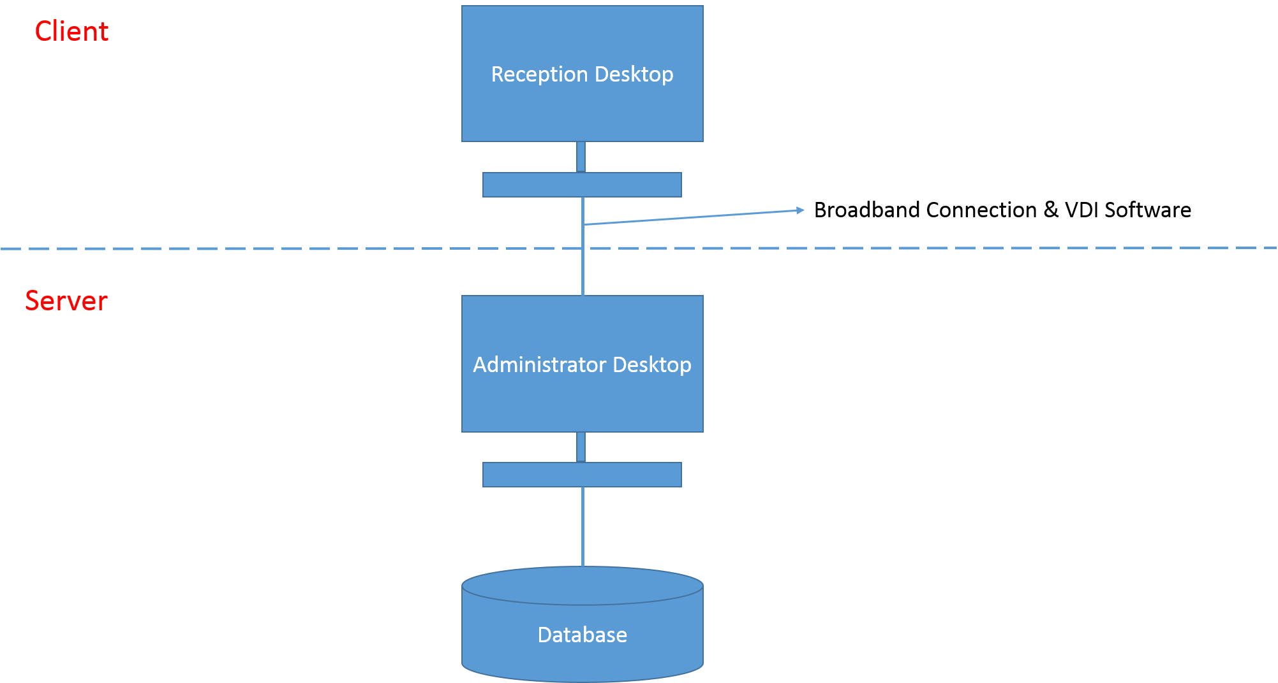

The Client of this architecture consists of 2 desktop computers. First is the reception desktop and second is the administrator desktop. Both are able to process functions of the HMS. However the administrator desktop also acts as the server as it provides the reception desktop the HMS through a VDI software connected via broadband connection in the hotel. The server/administrator desktop accesses a separate large database in the administrator room. This means that whatever the reception desktop processes it will affect the one and same database which the administrator desktop accesses to as it uses the server (i.e. administrator desktop) to process the HMS.

USER INTERFACE (UI) DESIGN

User Interface Design is the design of user interfaces for machines and software to maximize the user experience. The goal of user interface design is to allow users to achieve their goals in a simple and efficient manner.
The form of the user interface used will be Windows form as it allows access to system resources on the computer and the level of access can be restricted to eliminate the possibility of unwanted access and any security risks.
Figure 1 below is a rough example of the Login screen. There will two text boxes where customers or staffs will have to enter their ID and password and a login button where they will have to click it after entering their ID and password to login.
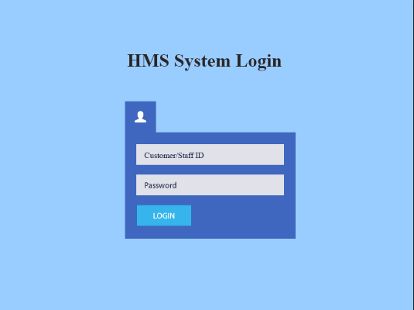
Figure 1

Figure 2 below is a rough example of the Booking screen. There are four buttons in this screen; the Create Booking button, Retrieve Booking button, Update Booking button, and Cancel Booking Button. I have chosen to use buttons for these functions as it will be easier and more straightforward for the users to get to the screens they would like to go to.
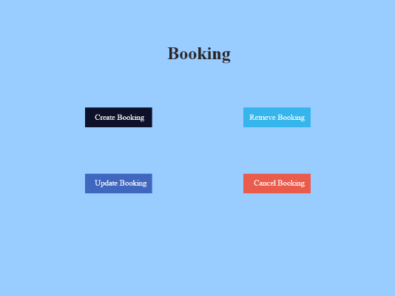
Figure 2

Figure 3 is a rough example of the Administer Users screen. It consists of four button, which are the Create User button, Change Password button, Modify User button and Delete User button. I have decided to use buttons for these steps as it is more straightforward and each buttons serve a different purpose, which will eventually lead to its respective screens that allows users to complete their tasks.
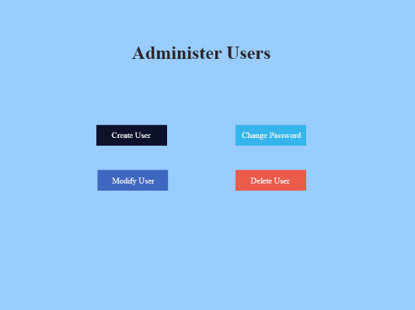
Figure 3

Figure 4 below is a rough example of the Administer Room screen. The design of this interface is simple with just three details, the Room Number, Room Type and the Rates of the chosen room. For the Room Number and Room Type, I have decided to use the drop-down list as it will be easier and more convenient for the users to look through and select their desired room instead of having them to manually entering it. I have added a Check Availability button at the bottom so that once the users click on the button, it shows them if their selected room is available.
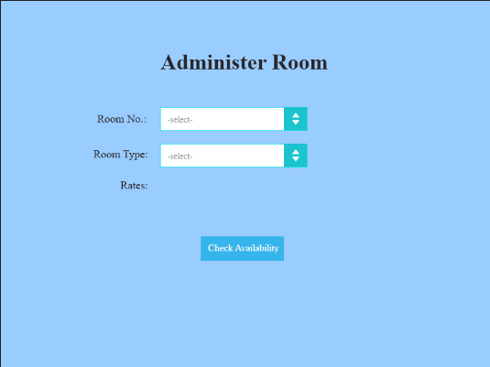
Figure 4

PROGRAM DESIGN

Use Case Diagram
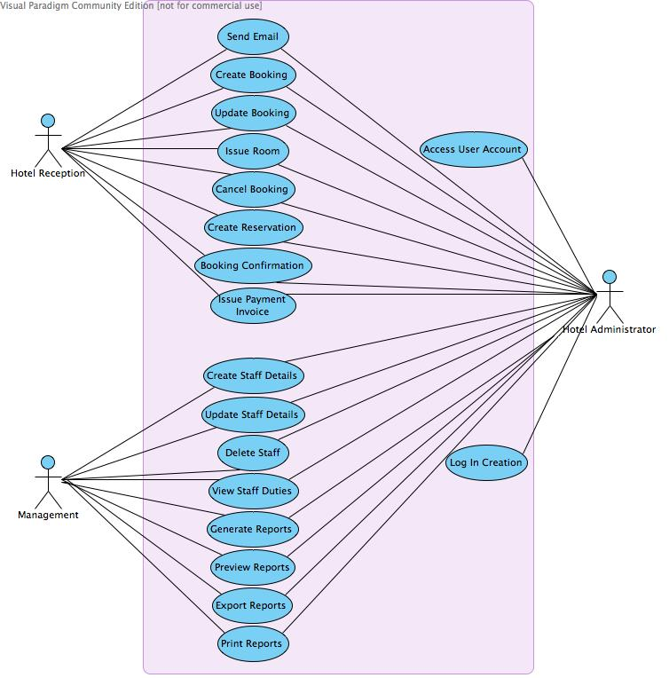

Booking VOPC
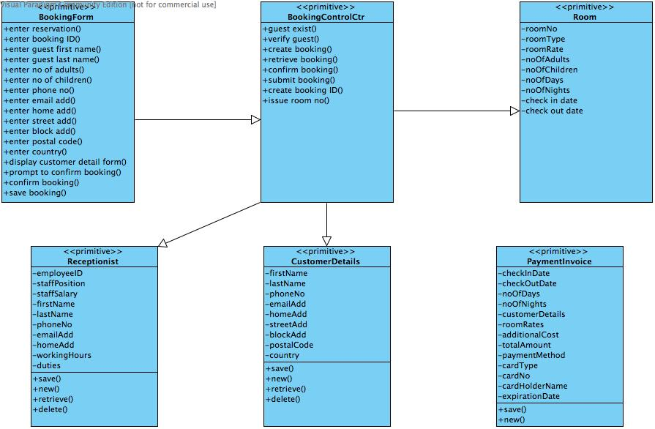

Housekeeping & Staff Management VOPC
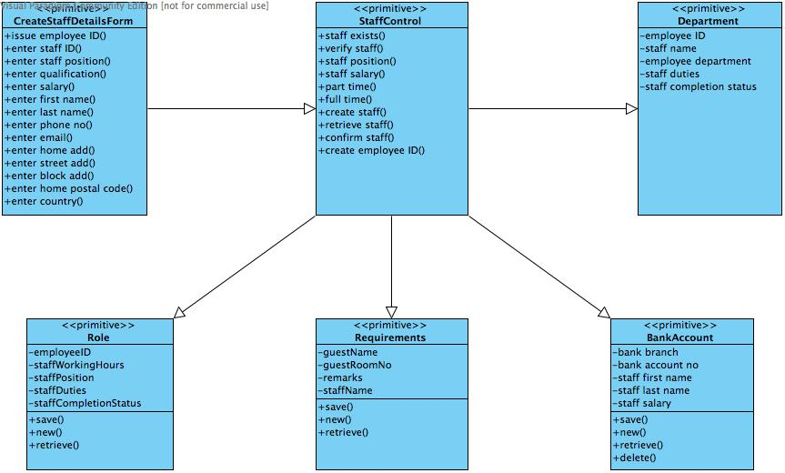

Reporting VOPC
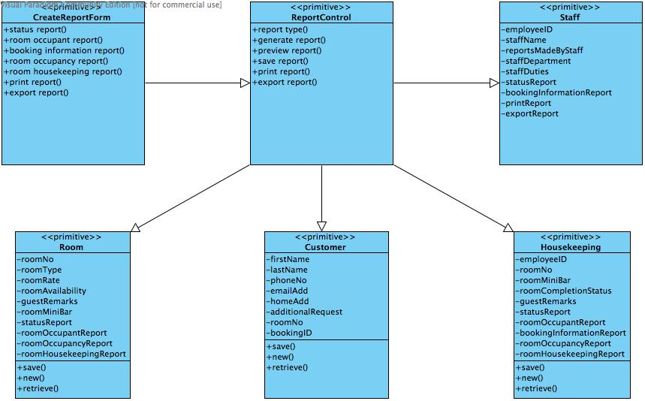

DATABASE DESIGN
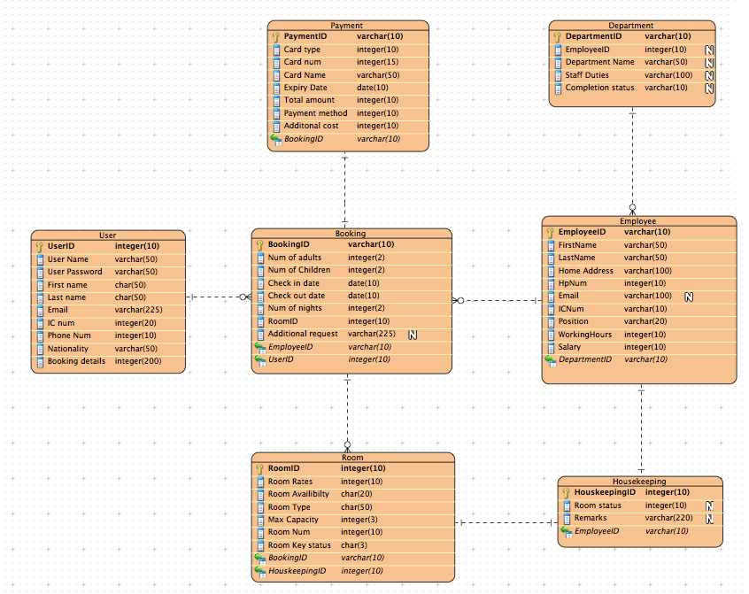
Figure 5.1 (Database Schema)

Before designing this database schema, I was going through the net on how to create an efficient database schema and I found out that normalized schema is an excellent method of organizing the database making it less complex. So the hotel staff will not have a hard time monitoring and making any changes in the database. The complexity of the database is reduced because I spilt the up into smaller components as seen in Fig. 5.1 adopting the OLTP example. OLTP is a best example of a normalized schema as it aims to have multiple tables instead of one to reduce the inconsistency. As you can see all the guest table and bookings table are not in the same tables in Fig 5.1 as one. Following the OLTP, it is not wise to if to have only one table as whenever the guest wants to book a room or update the particulars of the guest, it will have many rows to update making in very messy and least consistent. Hence, this will affect the performance and concurrency of the database and affect the bookings of hotel rooms, resulting in a loss of time and profit for the hotel.

Why I decided to model in OLTP? It is because proper OLTP database is able to handle a lot of users at the same time preferably with a low latency. Customers will be frustrated, as they have to keep waiting for their turn to book a hotel room so user experience is very important. It also has a short response time compared to other database system and this will ensure the database is productive 24/7, 365 days a year. With simple database commands, staff can see the selected rows they want to see on the database, as only the rows will be displayed. The data maintains is mainly a issued, as traditional database will be down for a maintenance but a OLTP allows maintenance to be run in the background while users and staff are still able to book hotel rooms and process the bookings made by the users.

I adopted OLTP into my design is also because it allows partitioning which is the solution to solve my data storage requirements. Partitioning will help to reduce the space requirements as selected parts of the database can be compressed. Partitioning will allow lower the cost of storing vast amount of data, as data are stored transparently on different storage tiers.

My database schema is not perfect as they are some limitations such as:
- Financial transaction processing cost
OLTP deals with a lot of online transactions so booking of hotel rooms by the user will impose a large cost on all the cost on financial transaction processing as they paid through their debit or credit cards. Hence, financial institutions will impose cost of booking on the hotel. Might be charged on a monthly basis or at minimum fees.

- Atomicity
Atomicity refers to a booking transaction in which either all the database steps succeed or entirely failed. If any one step goes wrong, and the transaction continues anyway, you'll probably end up with data errors or corruption. That could be devastating for hotel.

Interesting/innovative Portions that needs to explain:
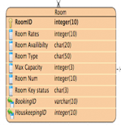
Fig 5.2 Room

The room table refer to the BookingID is because whenever the room is booked the hotel staff knows who the room is booked by. By tracking the BookingID and this will ensure other users will not book the room on the same date. This will reduce the miscommunications and problems that will surface if the room is being booked twice on the same period of time.

The HousekeepingID is being reference because it allows the hotel receptionist to keep track of the room status and knowing whether the room has been prepared for the guest to check in their room.

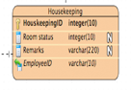
Fig 5.3 Housekeeping

In this design the EmployeID is being reference by the housekeeping table is because this allow the management to know who have performed housekeeping duties on the room and whether the respective staff was doing their job.

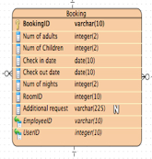
Fig 5.4 Booking Table

EmployeeID is referenced by the booking table is because if any part of the transaction went wrong, the management is able to know which staff have process the booking and he or she can resolve the matter in the shortest period of time.

UserID is also referenced by the booking table because this allows the staff to know who has make the hotel booking and can provide after transaction services such as sending messages to the user account to remind the user on their stay at the hotel.

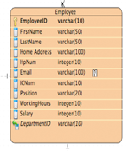
Fig 5.5 Employee Table

DepartmentID is being referenced so the management knows which departments does the staff belong to.

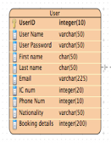
Fig 5.6 User Table

This table is created to allow guest to have their account and it allows easy management for the hotel administrators as all the user particulars can be easily retrieve and promotions or any news can be passed to the user easily. This will improved the user experience and the user knows the hotel is very user orientated and will return for more stays at the hotel.

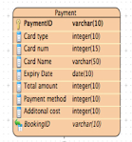
Fig 5.7 Payment Table

BookingID is referenced here, as it will allow the payment table to know how much the guest will have to pay to the hotel. In order to finish the booking of hotel rooms before being processed by the Hotel staff.

References
http://frankdenneman.nl/2014/09/23/database-workload-characteristics-impact-storage-architecture-design-part-1/
http://docs.oracle.com/cd/B28359_01/server.111/b32024/part_oltp.htm
http://www.ehow.com/list_6403498_disadvantages-online-transaction-processing.html

